Class description

Class description-teacher_login

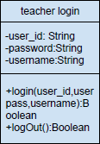

Description: This teacher _login class model that teacher login System

Attribute:

|  |  |  |  |
| --- | --- | --- | --- |
| No. | Name | Description | Type |
| 1 | user_id | The unique identifier teacher | String |
| 2 | password | Password of teacher | String |
| 3 | username | Username of teacher | String |

Class description-delete_class

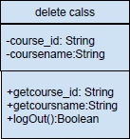

Description: This delete_class model that teacher delete class

Attribute:

|  |  |  |  |
| --- | --- | --- | --- |
| No. | Name | Description | Type |
| 1 | course_id | The unique identifier course | String |
| 2 | course_name | Name of course | String |

Class description-teacher _select

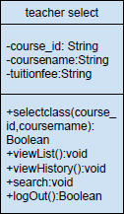

Description: This teacher_select class model that teacherview course information

Attribute:

|  |  |  |  |
| --- | --- | --- | --- |
| No. | Name | Description | Type |
| 1 | course_id | The unique identifier course | String |
| 2 | coursename | Name of course | String |
| 3 | tuitionfee | tuitionfee of course | String |

Class description-teacher_addclass

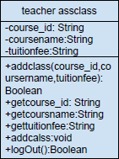

Description: This teacher_addclass class model that teacheradd course

Attribute:

|  |  |  |  |
| --- | --- | --- | --- |
| No. | Name | Description | Type |
| 1 | course_id | The unique identifier course | String |
| 2 | coursename | Name of course | String |
| 3 | tuitionfee | tuitionfee of course | String |

Class method description

Class teacher_login



Methods:

|  |  |  |  |  |
| --- | --- | --- | --- | --- |
| No. | Name | Description | Parameter List | Return Type |
| 1 | login | Use to login to the system | String user_id,userpass,username | boolean |
| 2 | logOut | Use to log out from the system | - | boolean |

Class delete_class



Methods:

|  |  |  |  |  |
| --- | --- | --- | --- | --- |
| No. | Name | Description | Parameter List | Return Type |
| 1 | deleteclass | Use to delete course class | String course_id,coursername,tuitionfee | boolean |
| 2 | getcourse_id | Use to get course id | - | void |
| 3 | getcoursname | Use to get course name | - | void |
| 4 | gettuitionfee | Use to get tuitionfee | - | void |
| 5 | deletecalss | Use to delete calss | - | void |
| 6 | logOut | Use to log out from the system | - | boolean |

Class teacher_select



Methods:

|  |  |  |  |  |
| --- | --- | --- | --- | --- |
| No. | Name | Description | Parameter List | Return Type |
| 1 | selectclass | Use to select course class | String course_id,coursename | boolean |
| 2 | viewList | Use to view course list | - | void |
| 3 | viewHistory | Use to view course history | - | void |
| 4 | search | Use to search course | - | void |
| 5 | logOut | Use to log out from the system | - | boolean |

Class teacher_addclass



Methods:

|  |  |  |  |  |
| --- | --- | --- | --- | --- |
| No. | Name | Description | Parameter List | Return Type |
| 1 | addclass | Use to add course class | String course_id,coursername,tuitionfee | boolean |
| 2 | getcourse_id | Use to get course id | - | void |
| 3 | getcoursname | Use to get course name | - | void |
| 4 | gettuitionfee | Use to get tuitionfee | - | void |
| 5 | addcalss | Use to add calss | - | void |
| 6 | logOut | Use to log out from the system | - | boolean |